Smart Study AI: Personalized Learning and Revision Platform

Submitted by

POOJA A K (230701226)
in partial fulfilment of the award of the degree of

BACHELOR OF ENGINEERING IN
COMPUTER SCIENCE AND ENGINEERING



RAJALAKSHMI ENGINEERING COLLEGE

ANNA UNIVERSITY, CHENNAI MAY 2026

BONAFIDE CERTIFICATE

Certified that this Project titled Smart Study AI: Personalized Learning and Revision Platform is the bonafide work of POOJA A K who carried out the work under my supervision. Certified further that to the best of my knowledge, the work reported herein does not form part of any other thesis or dissertation on the basis of which a degree or award was conferred on an earlier occasion on this or any other candidate.

SIGNATURE

Mrs B.Deepa M.E., (Phd)., Computer Science & Engineering Rajalakshmi Engineering College Thandalam, 602105

Submitted for the End Semester Practical Examination to be held on

INTERNAL EXAMINER EXTERNAL EXAMINER

ABSTRACT
Smart Study AI is an intelligent AI-powered educational application designed to improve the learning experience through personalized academic assistance and smart learning tools. The application integrates features such as AI-based note summarization, flashcard generation, quiz creation, voice-enabled doubt clarification, revision planning, and performance analytics within a single platform. The system helps students simplify studying and revision by providing automated and interactive learning support.
Users can upload PDF documents and text notes, which are processed using AI technologies to generate concise summaries, important concepts, flashcards, and quiz questions automatically. The application also includes an AI chatbot that allows users to ask doubts using both text and voice interaction through speech recognition and text-to-speech technologies.
To improve learning efficiency, the system includes Smart Weakness Detection and AI Revision Planner modules that analyze user performance and generate personalized study recommendations and schedules. Advanced analytics dashboards are also provided to track study progress, quiz accuracy, topic mastery, and learning consistency.
The application is developed using React Native, Firebase cloud services, and OpenAI APIs while following modular and scalable architecture principles. It supports secure multi-user authentication, real-time cloud synchronization, and smooth navigation across multiple screens. Overall, Smart Study AI provides a scalable, intelligent, and user-friendly digital learning platform that combines artificial intelligence, analytics, and adaptive learning support into a single modern educational ecosystem.

ACKNOWLEDGEMENT
Initially, we thank the Almighty for being with us through every walk of our life and showering his blessings through the endeavour to put forth this report. Our sincere thanks to our chairman Mr. S. MEGANATHAN, B.E, F.I.E., our respected Chairperson Dr. (Mrs.) THANGAM MEGANATHAN, Ph.D., our Vice Chairman Mr. ABHAY SHANKAR MEGANATHAN, B.E, M.S., for
providing us with the requisite infrastructure and sincere endeavouring in educating us in their premier institution.
Our sincere thanks to Dr. S.N. MURUGESAN, M.E., Ph.D., our beloved principal for his kind support and facilities provided to complete our work in time. We express our sincere thanks to Dr. E.M.MALATHY, M.E., Ph.D., Professor and Head of the Department of Computer Science and Engineering and our mentor Mrs B.Deepa M.E., (Phd)., Department of Computer Science and Engineering for his useful tips during our review to build our project.

TABLE OF CONTENTS

CHAPTER | TITLE | PAGE NO
 | ABSTRACT
 | ACKNOWLEDGEMENT
1 | INTRODUCTION | 01
1.1 | GENERAL | 01
1.2 | SCOPE OF THE WORK | 01
1.3 | AIM & OBJECTIVES OF THE PROJECT | 02
2 | LITERATURE SURVEY | 03
3 | SYSTEM DESIGN | 05
3.1 | ARCHITECTURE DIAGRAM | 05
3.2 | USE CASE DIAGRAM | 06
3.3 | HARDWARE SPECIFICATIONS | 07
3.4 | SOFTWARE SPECIFICATIONS | 08
4 | PROPOSED SYSTEM | 10
5 | MODULE DESCRIPTION | 12
6 | OUTPUT | 14
7 | CONCLUSION AND FUTURE ENHANCEMENTS | 15
8 | REFERENCES | 17

CHAPTER 1

INTRODUCTION
  - General

Smart Study AI is an AI-powered educational application designed to provide an intelligent and personalized learning experience through a single integrated platform. The system combines multiple academic features such as AI-based note summarization, flashcard generation, quiz creation, voice-enabled doubt clarification, revision planning, and performance analytics within one application. Users can upload PDF documents or text notes, which are processed using AI models to generate summaries, important concepts, quizzes, and flashcards automatically.
The application also includes an AI chatbot that helps students clarify doubts using both text and voice interaction. Smart Study AI focuses on improving study productivity and learning efficiency through intelligent recommendations, adaptive learning support, and interactive analytics dashboards. Overall, the platform provides a scalable, user-friendly, and future-ready digital learning solution.

1.2 Scope of the Work

Smart Study AI focuses on developing an intelligent educational platform that simplifies studying, revision, and academic tracking using artificial intelligence technologies.
• Upload PDF documents and text notes
• Generate AI-powered summaries and flashcards
• Create AI-based quizzes and MCQs
• Provide AI chatbot support for doubt clarification
• Support voice-based interaction
• Detect weak topics through quiz analysis
• Generate personalized revision schedules
• Track study progress using analytics dashboards
• Maintain secure multi-user authentication and cloud synchronization
The scope also includes integrating AI services, cloud storage, speech recognition, and adaptive learning systems to provide a smooth, intelligent, and interactive learning experience.

1.3 Aim and Objectives of the Project

The aim of the Smart Study AI project is to develop an intelligent, scalable, and user-friendly AI-powered learning platform that improves study productivity and academic performance through automation and personalization.
The project enables users to upload study materials and automatically generate summaries, flashcards, quizzes, and important concepts using AI technologies. It also incorporates an AI chatbot for doubt clarification and voice-based interaction using speech recognition and text-to-speech features.
The system includes Smart Weakness Detection and AI Revision Planning modules to analyze user performance and provide personalized study recommendations. Firebase Authentication and Firestore Database are used to ensure secure multi-user access and cloud synchronization.
Overall, the objective of the project is to build a modern AI-powered educational ecosystem that combines intelligent learning assistance, voice interaction, analytics, and adaptive study support within a single scalable application.

CHAPTER 2 LITERATURE SURVEY
Research on AI-powered educational applications highlights the increasing importance of intelligent learning platforms that provide personalized academic assistance, automated content generation, and adaptive learning experiences. Existing studies emphasize the role of artificial intelligence, cloud computing, and mobile technologies in improving learning efficiency, revision quality, and student engagement [1], [2].
Modern educational systems focus on integrating multiple academic tools such as note summarization, quiz generation, flashcards, and chatbot assistance into a single platform. Studies show that AI-based tutoring systems help students understand concepts faster by providing automated explanations, contextual guidance, and personalized recommendations. Intelligent summarization systems also reduce information overload by extracting important concepts from large study materials [3], [6].
Adaptive learning and performance analytics play a major role in modern educational platforms. Research indicates that personalized recommendation systems and smart analytics help identify weak topics, track learning consistency, and improve academic performance through targeted revision strategies [4], [7].
Voice-enabled educational systems are becoming increasingly popular due to advancements in speech recognition and text-to-speech technologies. Studies show that voice interaction improves accessibility and user engagement by allowing hands-free communication with AI assistants. AI chatbots integrated with natural language processing further enhance learning support by enabling conversational doubt clarification [5], [8].
From an architectural perspective, scalable cloud-based systems and modular application design are essential for educational platforms. Firebase services, REST APIs, and component-based architectures are widely adopted to ensure secure authentication, real-time synchronization, maintainability, and multi-user support [3], [9].
Recent developments in educational analytics emphasize the importance of dashboards, progress tracking, and predictive analysis for monitoring student performance. Data visualization techniques such as progress graphs, mastery charts, and performance indicators help students better understand their academic growth and improve productivity [6], [10].
Overall, the literature suggests that AI-powered educational platforms are evolving toward highly intelligent, scalable, and personalized ecosystems that combine automation, analytics, voice interaction, and adaptive learning support into a single application. These advancements provide a strong foundation for developing systems like Smart Study AI.

CHAPTER 3 SYSTEM DESIGN
  - ARCHITECTURE DIAGRAM
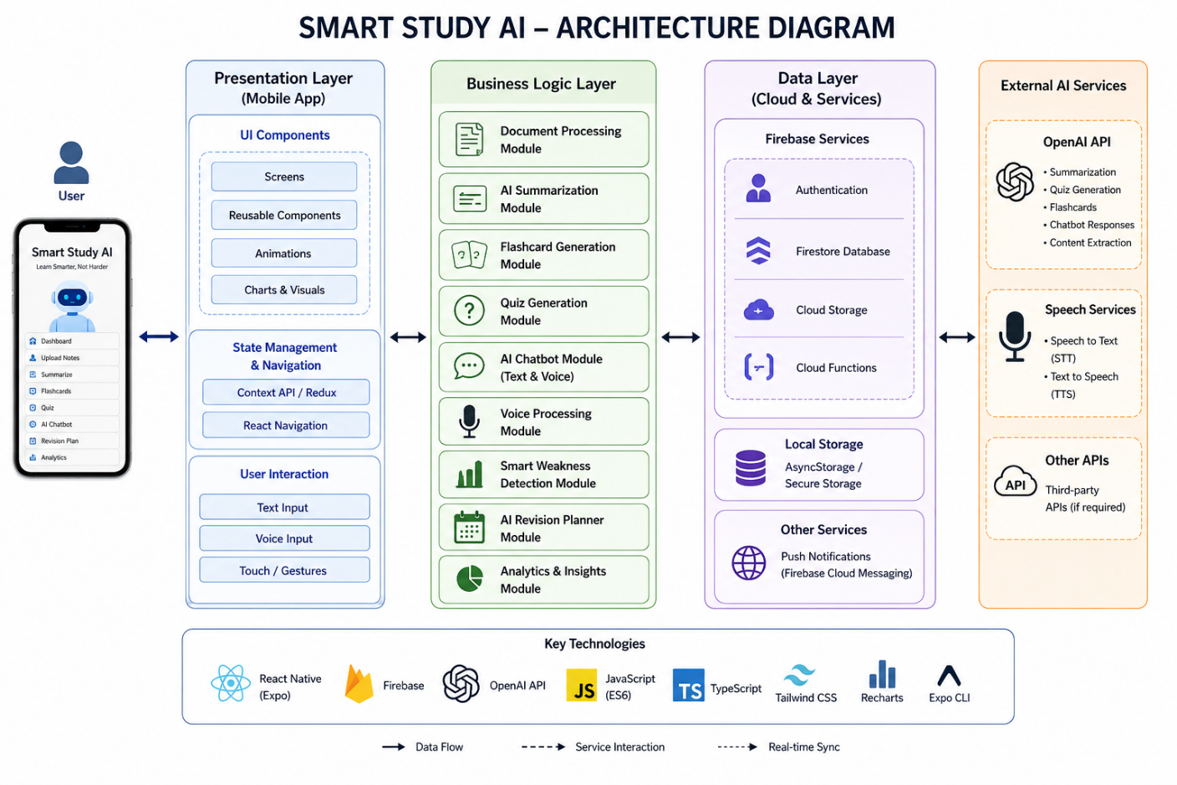

Fig 3.1.1 Architecture Diagram

Smart Study AI follows a modular and scalable architecture to support its AI-powered educational platform efficiently. The system is divided into three main layers: Presentation Layer, Business Logic Layer, and Data Layer. The Presentation Layer handles the user interface, navigation, animations, and user interactions through screens and reusable components. The Business Logic Layer manages core functionalities such as AI summarization, quiz generation, flashcard creation, chatbot processing, voice interaction, and revision planning. The Data Layer manages cloud storage, authentication, APIs, and database communication using Firebase services and OpenAI APIs.
The architecture integrates external AI services and speech-processing APIs to provide intelligent learning assistance, voice-enabled interaction, and adaptive recommendations. It also uses real-time cloud synchronization to maintain secure multi-user data management and smooth application performance. Overall, the system is modular, scalable, efficient, and designed to provide a seamless and intelligent learning experience.

USE CASE DIAGRAM
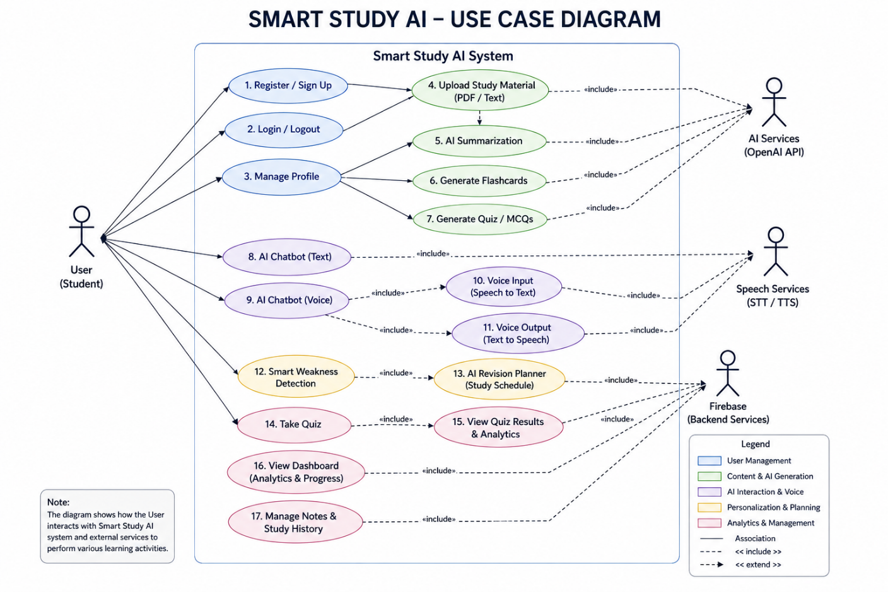

Fig 3.2.1 Use Case Diagram

The use case diagram of Smart Study AI illustrates how users interact with the AI-powered learning platform to access various educational services. Users can create accounts, log in securely, upload study materials, generate summaries, create flashcards, attend quizzes, and interact with the AI chatbot using both text and voice commands. The system also allows users to access personalized revision plans, performance analytics, and study recommendations based on learning patterns.
The application communicates with external AI services and cloud databases to process uploaded notes, generate intelligent responses, and synchronize user data in real time. It also analyzes quiz performance to identify weak topics and provide adaptive learning support. Overall, the system ensures a smooth, interactive, and personalized learning experience for students.

HARDWARE SPECIFICATIONS

The Smart Study AI application is designed to run efficiently on modern mobile devices and computing systems while supporting AI processing, cloud synchronization, and voice interaction features.

DEVELOPMENT SYSTEM REQUIREMENTS

• Processor: Intel Core i5 or higher
• RAM: Minimum 8 GB
• Storage: Minimum 20 GB free space
• Operating System: Windows 10 / macOS / Linux
• Development Tools: Visual Studio Code / Android Studio

SERVER REQUIREMENTS

• Backend Services: Firebase Cloud Services
• AI Services: OpenAI APIs
• Database: Firestore Database
• Network: Stable internet connection for API communication and cloud synchronization
These hardware requirements ensure smooth AI processing, real-time synchronization, voice interaction, and efficient application performance across all learning modules.

SOFTWARE SPECIFICATIONS
The Smart Study AI application is developed using modern software technologies to ensure scalability, intelligent automation, secure cloud integration, and smooth user experience.

Frontend Software Requirements
• Programming Language: JavaScript / TypeScript
• Framework: React Native (Expo)
• UI Design: Tailwind CSS / Native Components
• Architecture: Component-Based Architecture
• Navigation: React Navigation
• Animation Library: Framer Motion / Reanimated
• Development Environment: Visual Studio Code
The frontend is responsible for rendering dynamic user interfaces, managing navigation, handling animations, and providing smooth interactions across all educational modules.

Backend Software Requirements

• Backend Platform: Firebase
• API Type: REST APIs
• Database: Firestore Database
• Authentication: Firebase Authentication
• Cloud Storage: Firebase Storage

The backend layer handles authentication, real-time synchronization, secure communication, and AI data processing.

Artificial Intelligence Services
• AI Engine: OpenAI API
• AI Features:
- Summarization
- Quiz Generation
- Flashcard Creation
- AI Chatbot Responses
- Personalized Recommendations

Voice Processing Services

• Speech Recognition: Web Speech API / Native Speech APIs
• Text-to-Speech: Speech Synthesis APIs
These services provide intelligent learning assistance and complete voice-enabled interaction.

Version Control

• Platform: Git
• Repository Hosting: GitHub
Version control is used to manage source code, track changes, and support collaborative development.

Operating System Requirements

• Development: Windows / macOS / Linux
• Deployment: Android OS

Other Supporting Tools

• Build System: Expo CLI
• API Testing Tools: Postman (optional)
• Emulator: Android Emulator / Physical Device

These software components ensure that Smart Study AI operates efficiently, supports AI-powered learning services, and delivers a smooth, secure, and intelligent educational experience.

CHAPTER 4 PROPOSED SYSTEM
The proposed system, Smart Study AI, is an intelligent AI-powered educational platform designed to provide students with a centralized and interactive learning environment. The primary goal of the system is to simplify studying, revision, and academic tracking by integrating multiple intelligent learning features such as AI-based summarization, flashcard generation, quiz creation, voice-enabled doubt clarification, revision planning, and analytics into a single application. The system focuses on improving learning efficiency, personalization, and accessibility through modern artificial intelligence technologies.
From a technical perspective, the application is developed using React Native and follows a modular and scalable architecture to ensure maintainability, flexibility, and smooth performance. The system consists of Presentation, Business Logic, and Data layers, where each layer handles specific functionalities such as UI rendering, AI processing, cloud synchronization, and data management. Firebase Authentication and Firestore Database are used to support secure multi-user access and real-time cloud synchronization.
The application integrates OpenAI APIs to generate summaries, flashcards, quizzes, and intelligent chatbot responses from uploaded PDF documents and text notes. These AI services are processed efficiently to provide fast and responsive interactions without affecting application performance. The system also supports voice-based interaction using speech recognition and text-to-speech technologies, allowing users to ask doubts and receive AI responses through voice commands.
To improve personalization, the system includes Smart Weakness Detection and AI Revision Planner modules that analyze quiz performance, learning consistency, and study patterns to identify weak topics and generate adaptive study schedules. The application also provides analytics dashboards that visualize study progress, quiz accuracy, topic mastery, and predicted academic performance through interactive charts and graphs.
The user interface of Smart Study AI is designed using modern UI principles such as glassmorphism, smooth animations, responsive layouts, and premium mobile-first design techniques to provide an engaging and visually appealing user experience. Overall, the proposed system combines artificial intelligence, voice interaction, cloud synchronization, adaptive learning, and intelligent analytics to create a scalable, efficient, and future-ready educational platform.

CHAPTER 5 MODULE DESCRIPTION

The Smart Study AI system is divided into multiple intelligent modules, each responsible for handling a specific functionality of the AI-powered educational platform. These modules work together to provide a seamless and interactive learning experience.

5.1 Authentication Module
This module manages user registration, login, logout, and secure authentication using Firebase Authentication. It ensures secure multi-user access, session management, and isolated user data storage.

5.2 Upload & Notes Management Module
This module allows users to upload PDF documents and text-based notes for AI processing. It securely stores and manages study materials using cloud storage services.

5.3 AI Summarization Module
This module processes uploaded study materials using AI models to generate concise summaries, important concepts, and highlighted key points for efficient revision.

5.4 Flashcard Generation Module
This module automatically creates interactive flashcards from uploaded notes. It helps students revise concepts quickly through swipe and flip-based learning interactions.

5.5 Quiz Generation Module
This module generates AI-based quizzes and MCQs from uploaded materials. It evaluates user performance, tracks quiz scores, and stores analytics for future recommendations.

5.6 AI Chatbot Module
This module provides intelligent doubt clarification through conversational AI interactions. Users can ask questions using text or voice commands and receive contextual AI-generated responses.

5.7 Voice Interaction Module
This module handles speech-to-text and text-to-speech functionalities. It enables complete voice-enabled learning by converting voice input into text and generating spoken AI responses.

5.8 Smart Weakness Detection Module
This module analyzes quiz performance and learning patterns to identify weaker academic topics. It provides personalized recommendations and improvement suggestions.

5.9 AI Revision Planner Module
This module generates adaptive study schedules based on exam dates, available study hours, weak topics, and quiz performance to improve revision efficiency.

5.10 Analytics Dashboard Module
This module visualizes study progress, quiz accuracy, topic mastery, learning consistency, and predicted academic performance using graphs and interactive charts.

5.11 User Management Module
This module manages user profile information, preferences, study history, and cloud synchronization while ensuring secure data persistence across sessions.

5.12 Navigation & UI Module
This module manages the overall user interface, screen navigation, animations, and smooth transitions between screens while maintaining a consistent and premium user experience.

CHAPTER 6
OUTPUT
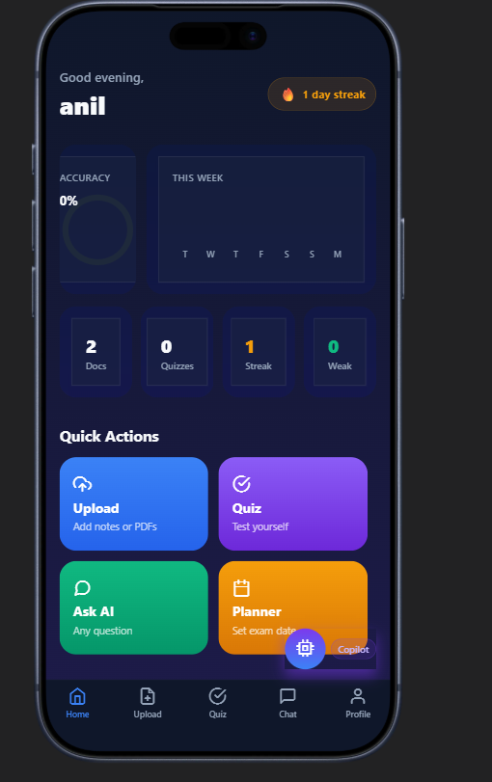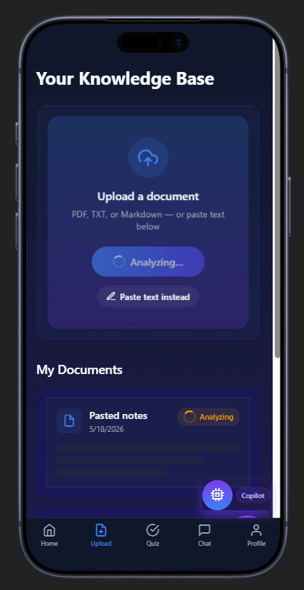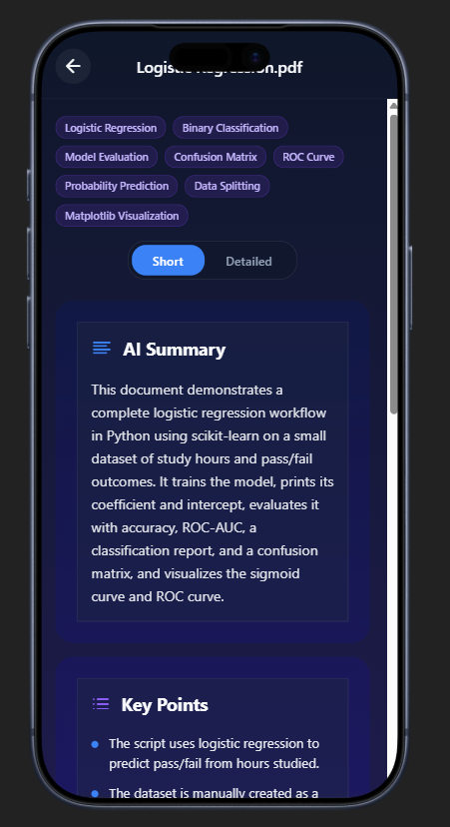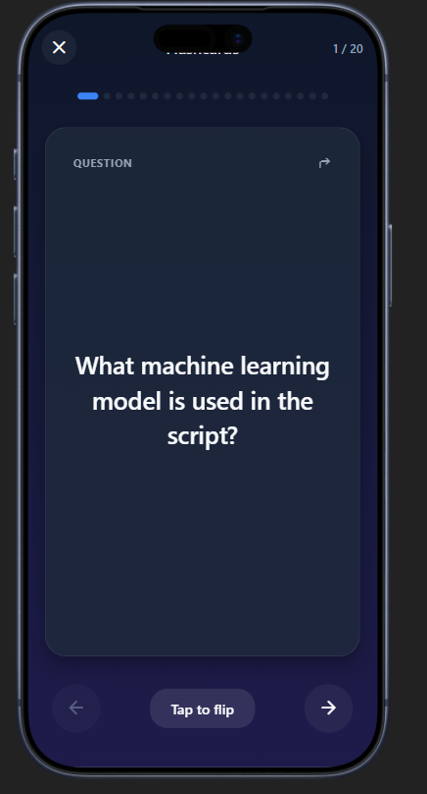

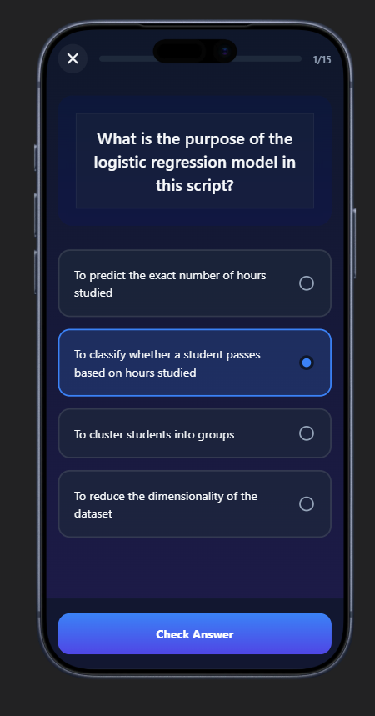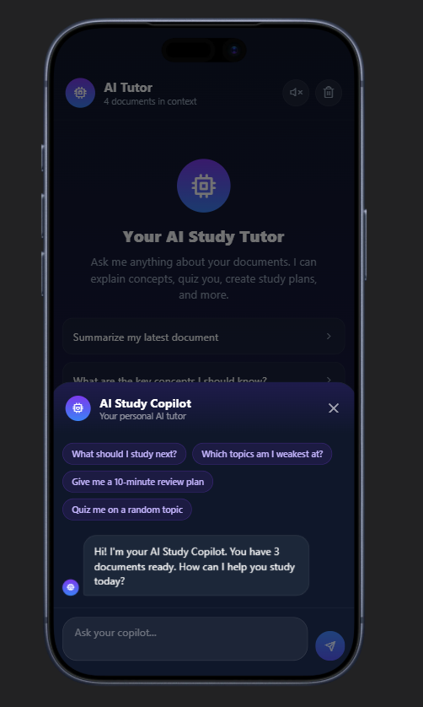

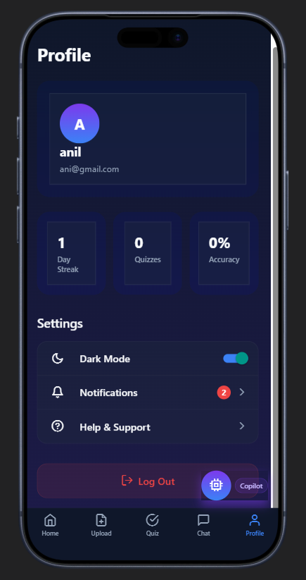

CHAPTER 7
CONCLUSION AND FUTURE ENHANCEMENTS

Conclusion:

Smart Study AI presents an intelligent and unified solution for modern digital learning by integrating AI-powered academic assistance, voice interaction, adaptive revision planning, and performance analytics into a single platform. The system simplifies studying and revision by providing automated summaries, flashcards, quizzes, and real-time doubt clarification through an AI chatbot. With features such as Smart Weakness Detection, personalized study recommendations, voice-enabled interaction, and analytics dashboards, the application enhances learning efficiency, productivity, and user engagement.
From a technical perspective, the use of modern technologies such as React Native, Firebase cloud services, OpenAI APIs, and modular architecture ensures that the system is scalable, maintainable, secure, and high-performing. The application also supports secure multi-user authentication and real-time cloud synchronization, providing a smooth and personalized learning experience. Overall, Smart Study AI demonstrates how artificial intelligence and cloud technologies can be effectively integrated to create a future-ready educational ecosystem that improves academic performance and learning accessibility.

Future Enhancements:

The Smart Study AI system can be further enhanced by introducing advanced intelligent learning features and expanding its educational capabilities. One of the major future improvements includes implementing AI-based handwriting recognition to convert handwritten notes into digital study materials automatically. The application can also integrate video-based learning recommendations, collaborative study rooms, and real-time exam simulations to improve engagement and interactive learning.
Further enhancements can include advanced AI recommendation systems for personalized learning paths based on user behavior and study performance. Additional analytics dashboards can provide deeper insights into productivity and academic growth. Security can also be improved through biometric authentication and stronger data encryption mechanisms. Features such as offline learning support, multi-language accessibility, smart notifications, and calendar synchronization can further improve usability and convenience.
Overall, these future enhancements will make Smart Study AI more intelligent, scalable, adaptive, and capable of supporting next-generation digital learning experiences.

CHAPTER 8 REFERENCES
- “Artificial intelligence-based personalised learning in education”
https://link.springer.com/article/10.1007/s44163-025-00598-x
- “AI in Education: A Review of Personalized Learning and Educational Technology”
https://www.researchgate.net/publication/390163119_AI_in_education_A_review_of_personalized_learning_and_educational_technology
- “Personalized Learning Through AI”
https://www.researchgate.net/publication/376814707_Personalized_learning_through_AI
- “AI-Powered Tutoring Systems: Revolutionizing Individualized Support for Learners”
https://www.researchgate.net/publication/387697612_Ai-Powered_Tutoring_Systems_Revolutionizing_Individualized_Support_For_Learners
- “AI-Driven Personalized Learning Systems: Enhancing Educational Effectiveness”
https://kuey.net/index.php/kuey/article/view/4961
- “Artificial Intelligence-Enabled Intelligent Assistant for Personalized and Adaptive Learning in Higher Education”
https://arxiv.org/abs/2309.10892
- “AI and Personalized Learning: Bridging the Gap with Modern Educational Goals”
https://arxiv.org/abs/2404.02798
- “The Impact of Artificial Intelligence on Personalized Learning”
https://www.mdpi.com/2813-4346/4/2/17
- “AIEd for Personalised Learning Pathways”
https://files.eric.ed.gov/fulltext/EJ1373006.pdf
- “AI in Education: Personalized Learning and Intelligent Tutoring Systems”
https://eajournals.org/ejcsit/vol13-issue32-2025/ai-in-education-personalized-learning-and-intelligent-tutoring-systems/

